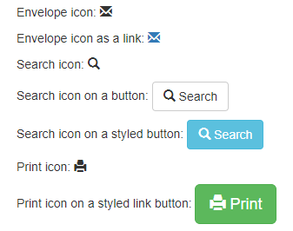

<!DOCTYPE html>

<html lang="en">

<head>

<title>Bootstrap Example</title>

<meta charset="utf-8">

<meta name="viewport" content="width=device-width, initial-scale=1">

<link rel="stylesheet" href="https://maxcdn.bootstrapcdn.com/bootstrap/3.4.1/css/bootstrap.min.css">

<script src="https://ajax.googleapis.com/ajax/libs/jquery/3.5.1/jquery.min.js"></script>

<script src="https://maxcdn.bootstrapcdn.com/bootstrap/3.4.1/js/bootstrap.min.js"></script>

</head>

<body>

<div class="container">

**<h2>Glyphicon Examples</h2>**

<p>Envelope icon: <span class="glyphicon glyphicon-envelope"></span></p>

<p>Envelope icon as a link:

<a href="#"><span class="glyphicon glyphicon-envelope"></span></a>

</p>

<p>Search icon: <span class="glyphicon glyphicon-search"></span></p>

<p>Search icon on a button:

<button type="button" class="btn btn-default">

<span class="glyphicon glyphicon-search"></span> Search

</button>

</p>

<p>Search icon on a styled button:

<button type="button" class="btn btn-info">

<span class="glyphicon glyphicon-search"></span> Search

</button>

</p>

<p>Print icon: <span class="glyphicon glyphicon-print"></span></p>

<p>Print icon on a styled link button:

<a href="#" class="btn btn-success btn-lg">

<span class="glyphicon glyphicon-print"></span> Print

</a>

</p>

</div>

</body>

</html>